EXPERIMENT NO : 3

1) BFS (Breadth First Search):-

PROGRAM:-
from collections import defaultdict
class Graph:
def __init__(self):
self.graph = defaultdict(list)
def addEdge(self, u, v):
self.graph[u].append(v)
def BFS(self, s):
visited = [False] * (max(self.graph) + 1)
queue = []
queue.append(s)
visited[s] = True
while queue:
s = queue.pop(0)
print(s, end=" ")
for i in self.graph[s]:
if visited[i] == False:
queue.append(i)
visited[i] = True
if __name__ == '__main__':
g = Graph()
g.addEdge(0, 1)
g.addEdge(0, 2)
g.addEdge(1, 2)
g.addEdge(2, 0)
g.addEdge(2, 3)
g.addEdge(3, 3)
print("Following is Breadth First Traversal"
" (starting from vertex 2)")
g.BFS(2)

OUTPUT:-

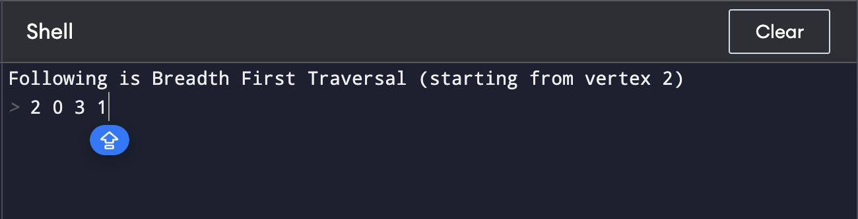

2) DFS (Depth First Search):-

PROGRAM:-
from collections import defaultdict
class Graph:
def __init__(self):
self.graph = defaultdict(list)
def addEdge(self, u, v):
self.graph[u].append(v)
def DFSUtil(self, v, visited):
visited.add(v)
print(v, end=' ')
for neighbour in self.graph[v]:
if neighbour not in visited:
self.DFSUtil(neighbour, visited)
def DFS(self, v):
visited = set()
self.DFSUtil(v, visited)
if __name__ == "__main__":
g = Graph()
g.addEdge(0, 1)
g.addEdge(0, 2)
g.addEdge(1, 2)
g.addEdge(2, 0)
g.addEdge(2, 3)
g.addEdge(3, 3)
print("Following is Depth First Traversal (starting from vertex 2)")
g.DFS(2)

OUTPUT:-
